QUES1. A.insert 5 record in the created data base student

b.list ale the info student form the table

c.list ale the student will be no with their courses where the course data base is created using the following .

d.list the course name and location from the course table

e. list the name of the student when student id is 7369 , 7777,2333

ans A

create table Student(StudentId number,Student_Name varchar2(30),Address varchar2(50),Gender varchar2(25),Course varchar2(30));

desc student;

insert into Student values(2333,'Riaz','oheo faridabad','male','Bca');

insert into Student values(7369,'mohit','icecream faridabad','male','Btech ');

insert into Student values(7777,'Astitva','green field faridabad','male','Bca');

insert into Student values(8888,'Yash','tuklakabad','male','Bca');

insert into Student values(9999,'Harsh','Sector 21A','male','mca');

select * from Student;

select studentId , Course from student;

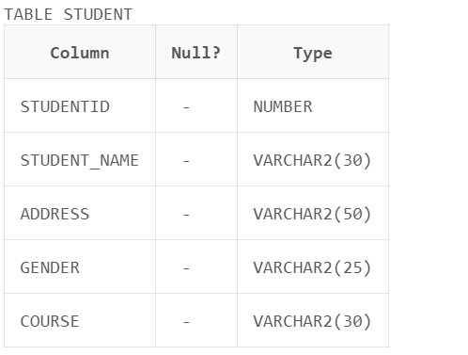

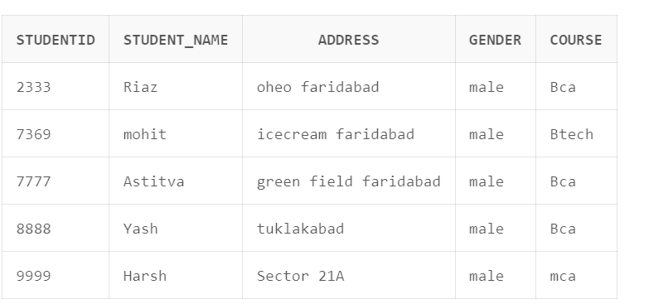

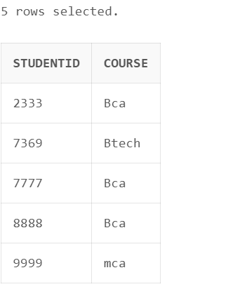

Ansb. create table Course (CourseId varchar2(30),Dept_No Number,D_name varchar2(25),Location varchar2(50));

insert into Course values('Bca',001,'Riaz','C-Block');

insert into Course values('Btech',003,'Yash','A-Block');

insert into Course values('Mca',002,'Astitva','o-Block');

select CourseId,Location from Course; 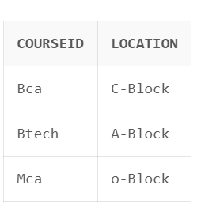

select * from student where Course='mca';

select * from Student where Studentid=7369 or Studentid='7777' or studentid='2333';

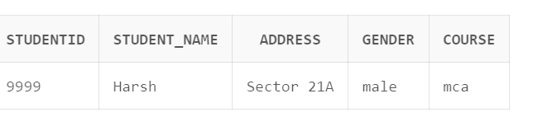

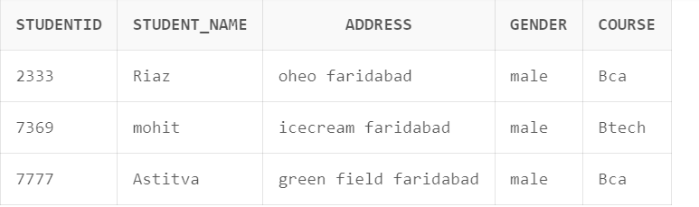

Ques. c.list ale the student will be no with their courses where the course data base is created using the following .